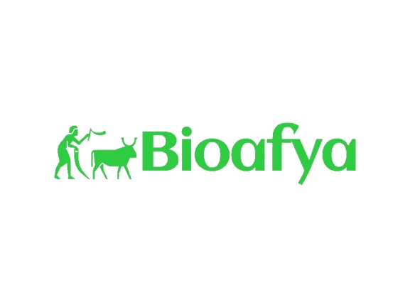

**TECHNICAL DOCUMENTATION**

**{BIO_AFYA}**

# **INTRODUCTION**

The Livestock Management System integrates automation, AI, and IoT technologies to improve livestock health monitoring, disease detection, and farm management. The system enables farmers to receive real-time health updates, early disease alerts, and automated recommendations for treatment and farm operations. By leveraging data-driven insights, the system enhances productivity, minimizes losses, and supports sustainable farming.

# **System Architecture (**how different components interact)

The system comprises several interdependent components working together to provide a seamless and intelligent livestock management experience.

### **1. IoT Sensor Network**

* Wearable IoT devices attached to livestock collect real-time data on temperature, heart rate, movement, and feeding behavior.
* Environmental sensors monitor humidity, temperature, and air quality in livestock shelters.
* Data is transmitted via wireless communication protocols (LoRa, Wi-Fi, or Bluetooth) to a centralized cloud database.

### **2. Data Processing & AI Analytics**

* **Data Aggregation:** Sensor data is continuously collected and sent to the cloud database for storage and processing.
* **AI & Machine Learning Algorithms:**
* **Anomaly Detection:** Identifies deviations in animal behavior that may indicate disease or distress.
* **Predictive Analytics:** Uses historical data to forecast potential outbreaks and recommend preventive measures.
* **Automated Diagnosis:** Cross-references symptoms with known disease patterns to provide preliminary health assessments.

### **3. Automation & Smart Alerts**

* Automated alerts are triggered based on abnormal sensor readings, notifying farmers via SMS, mobile app, or dashboard.
* Smart irrigation and feeding systems adjust water and food supply based on detected environmental conditions and livestock needs.
* RFID-based tracking assists in managing livestock movements and reducing theft.

### **4. Farmer Dashboard & Mobile Application**

**Dashboard Features:**

* + Real-time livestock health status overview.
  + Predictive reports for disease prevention and productivity trends.
  + Access to veterinary recommendations and treatment logs.

**Mobile App Functionalities:**

* + Instant notifications on livestock health and emergencies.
  + Manual input for vaccination records, breeding cycles, and feeding schedules.
  + AI-powered chatbot for quick consultation on farm issues.

### **5. Cloud Infrastructure & Data Security**

* **Cloud Storage:** Secure databases store sensor data, health records, and AI-generated insights.
* **Encryption & Access Control:** Ensures data integrity and prevents unauthorized access.
* **API Integration:** Enables seamless connection with external veterinary systems, government databases, and smart farm tools.

# **Technology Stack** (programming languages, frameworks, and tools used.)

The Livestock Management System is built using modern programming languages, frameworks, and tools to ensure efficiency, scalability, and security.

#### **1. Programming Languages**

* **JavaScript (Node.js)** – Backend development for handling API requests and real-time processing.
* **JavaScript (React Native)** – Mobile application development for cross-platform support.

#### **2. Backend Development**

* **Node.js with Express.js** – Server-side logic and API development.

#### **3. Frontend Development**

* **React Native** – Cross-platform mobile application for Android and iOS.

#### **4. Database Management**

* **Firebase** – Real-time database for instant updates and syncing.
* **MongoDB** – NoSQL database for handling unstructured sensor data.

#### **5. IoT & Embedded Systems**

* **ESP32 & LoRa Modules** – Enable wireless data transmission between sensors and cloud storage.
* **Arduino & Raspberry Pi** – Used for processing sensor data and transmitting it to the cloud.

#### **6. Cloud Services & Hosting**

* **Firebase Cloud Functions** – Handles serverless computing and backend logic.
* **Google Cloud & AWS** – Provides cloud storage, AI model hosting, and scalable computing resources.

#### **7. Communication Protocols**

* **MQTT** – Lightweight messaging protocol for IoT data transmission.
* **HTTP & WebSockets** – For API communication and real-time updates.

#### **8. Security & Authentication**

* **OAuth2 & JWT (JSON Web Tokens)** – For secure authentication and API access control.
* **SSL/TLS Encryption** – Ensures secure communication between system components.

# **APIs & Data Sources**

The system utilizes multiple APIs and external data sources to enhance its functionalities, provide real-time insights, and ensure seamless communication between different components.

## **1. Internal APIs**

* **Sensor Data API**: Collects real-time data from IoT sensors and transmits it to the database.
* **Livestock Health API**: Processes data to detect anomalies and provides health insights based on AI models.
* **Alerts & Notifications API**: Sends SMS, push notifications, and emails to farmers when critical livestock conditions are detected.
* **Farm Analytics API**: Generates reports on animal health trends, disease outbreaks, and productivity metrics.

## **2. External APIs**

* **Weather API (OpenWeatherMap, NOAA, or WeatherStack)**: Provides weather forecasts to help farmers plan for adverse conditions affecting livestock health.
* **Veterinary Database API**: Integrates with veterinary services to provide disease information, treatment suggestions, and professional assistance.
* **Government & Agricultural APIs**: Fetches official livestock regulations, market trends, and disease control measures.
* **Geolocation & Mapping APIs (Google Maps, OpenStreetMap)**: Helps track livestock locations and navigate to veterinary services or supply centers.

## **3. Data Sources**

* **IoT Sensor Data**: Captures real-time environmental and animal biometric information.
* **Historical Health Records**: AI models analyze past data to predict disease outbreaks and recommend preventive measures.
* **Farm Input & Management Data**: User-inputted details about feeding schedules, vaccination history, and breeding cycles.
* **Public Datasets**: Uses global and regional datasets on livestock health, climate change, and disease patterns to improve prediction accuracy.

## **4. API Workflow & Integration**

1. **Sensor Data API** collects real-time inputs and stores them in Firebase and MongoDB.
2. **Livestock Health API** processes data and applies AI models for anomaly detection.
3. **Weather API** fetches external weather data and correlates it with livestock health conditions.
4. **Alerts API** sends notifications to farmers based on predefined health thresholds.
5. **Geolocation API** provides navigation assistance for reaching veterinary services.
6. **Analytics API** generates farm reports accessible through the dashboard or mobile app.

# **Conclusion**

The use of **Node.js, React Native, Firebase, and MongoDB** provides a **scalable, efficient, and user-friendly** platform for farmers, veterinarians, and agricultural stakeholders. Through **APIs and external data sources**, the system incorporates weather forecasts, veterinary databases, and government regulations to offer **holistic farm insights**.

The Livestock Management System provides an intelligent, automated, and data-driven approach to livestock farming. By integrating IoT, AI, and cloud computing, the system empowers farmers with real-time insights, enhances disease prevention, and improves overall farm efficiency. This innovative solution plays a crucial role in modernizing agriculture and ensuring sustainable livestock management.